# A

# PROJECT REPORT

# ON

**“BookMyMaid”**

SUBMITTED IN

PARTIAL FULFILLMENT OF THE REQUIREMENT

FOR THE COURSE OF DIPLOMA IN ADVANCED COMPUTING FROM CDAC



**Institute of Emerging Technologies, PUNE**

**SUBMITTED BY:**

Akshaykumar Girmal 220345920009

Atharva Bondre 220345920024

Tejas Jawale 220345920049

Mayur Nigade 220345920057

Pankaj Desai 220345920069

Ruchita Patil 220345920083

**UNDER THE GUIDENCE OF:**

Prof.Shrinivas Dudhani

Faculty Member

Institute of Emerging Technologies, Pune



**Institute of Emerging Technologies, PUNE**

CERTIFICATE

This is to Certified that

* Akshaykumar Girmal 220345920009
* Atharva Bondre 220345920024
* Tejas Jawale 220345920049
* Mayur Nigade 220345920057
* Pankaj Desai 220345920069
* Ruchita Patil 220345920083

has satisfactorily carried and completed the project work entitled

“**BookMyMaid**”

This is to certify that the project work under the title ‘BookMyMaid’ is done by Group No. 16 in partial fulfillment of the requirement for award of Diploma in Advanced Computing Course.

**UNDER THE GUIDENCE OF:**

Prof.Shrinivas Dudhani

Faculty Member

Institute of Emerging Technologies, PUNE

**ACKNOWLEDGEMENT**

A project usually falls short of its expectation unless aided and guided by the right persons at the right time. We avail this opportunity to express our deep sense of gratitude towards Mr. Sangram Patil (Center Coordinator, IET, Pune) and Mr. Shrinivas Dudhani (Course Coordinator, IET, Pune).

We are deeply indebted and grateful to them for their guidance, encouragement and deep concern for our project. Without their critical evaluation and suggestions at every stage of the project, this project could never have reached its present form.

Last but not the least we thank the entire faculty and the staff members of Institute of Emerging Technologies, Pune for their support.

Akshaykumar Girmal 220345920009

Atharva Bondre 220345920024

Tejas Jawale 220345920049

Mayur Nigade 220345920057

Pankaj Desai 220345920069

Ruchita Patil 220345920083

E-DAC March 22 Batch,

IET Pune

**Table of Contents**

**1. Introduction 4**

1.1 Document Purpose **4**

1.2 Project Background **4**

1.3 Aim & Objectives **4**

**2. Business RequirementsOverview**…………………………………………………………**5**

**3.Functional Requirements** **5**

3.1 Customer Module **5**

3.2 Maid Module **6**

3.3 Admin Module **6**

**4.Non-FunctionalRequirement………………………………………………………………..6**

**5. Use Case Diagram 7**

5.1 Admin **7**

5.2 User **8**

5.3 Maid **9**

**6. Database Design 10**

1 Maid **10**

2 User **10**

3 Services…………………………………………………………………………………...**10**

4 Booking_info **11**

5 Maid_review……………………………………………………………………………..11

**7. Snapshots 13**

**8. Future Scope………………………………………………………………………………………..24**

**9. Conclusion 25**

**List of Figures**

**Use Case Diagrams 7**

Fig 1 Admin 7

Fig 2 Customer 8

Fig 3 Maid 9

1. **Introduction:**
   1. **Document Purpose:**

Online Maid Booking System is a system created to provide household help services to the customers

* 1. **Project Background:**

As we move to new city or place, it’s become quite troublesome to search for maid and then end up with no option...

So keeping in mind the problem we come up to the solution of booking online Maid ... where customer can book maid online by visiting our website.

* 1. **Aim & Objectives:**

The main objective of this project is building a website which will help maids to get the work.

Booking software is the backend of a business's online website. It empowers business owners to easily create a website to provide maids easily available by booking them for helping in household works like cleaning, washing, cooking, etc.

Here if suppose some maids want to use this facility and want to learn how it is possible and how they can use e-booking to register, they must have knowledge of computer then they can directly register in the site and get the work.

On the other side, customer can also register and book maid online as per their needs.

1. **Business Requirements Overview**

* Maid booking system is the public web application.
* Maid booking system will be opened to the global, but in the phase 1, the main target is in the India.
* There are mainly two types of user. One is the Customer and other is Maid.
* Customer can search for the maid available for household work.
* Maid booking system provides the functions which connect the customers and the maid efficiently.
* Maid booking system could be maintained by Administrator.

1. **Functional Requirements Overview**

Maid booking system consists of four modules described as below.

1. Customer Module
2. Maid Module
3. Admin Module
4. Message Acknowledgement Module

3.1 **Customer Module**

* Customer can register and create their account.
* Maid booking system provides the function which allows customer to search and book maid as per their need.
* Customer is able to browse existing list price of maid.
* Customer can view the history of their previous booked maid.
* Customer can update personal details.

3.2 **Maid Module**

* Maid can register and create their account.
* Maid booking system provides the function which allows maid to get the work.
* Maid can update personal details.

3.3 **Admin Module**

* Maid booking system should provide all function to admin how to handle the System.
* What are the customer and maid are using this system and are they authorized.
* Could able to know all the Transaction.

3.4 **Message Acknowledgement Module**

* Message Acknowledge Module should provide the entire users feedback message about their completion of transaction.
* Message Acknowledgement will send to both customer and maid for the booking.

**Non-functional Requirements**

* The website should use professional design, look and feel and color scheme.
* Users will have no limitations for accessing the application through Internet. The portal being an internet application, it is difficult specify exact number of visitor or users. Hence we will target the system to support between 5 and 10 million users on launch of phase 1.
* Being a public website, the site must follow general usability guidelines for menus, navigation, colors, links and other actions provided on the screens.
* The system should be designed in such a manner that user will be able to complete tasks in minimum number of steps.

.

**5. Use-Case Diagram**

**5.1 Admin:**

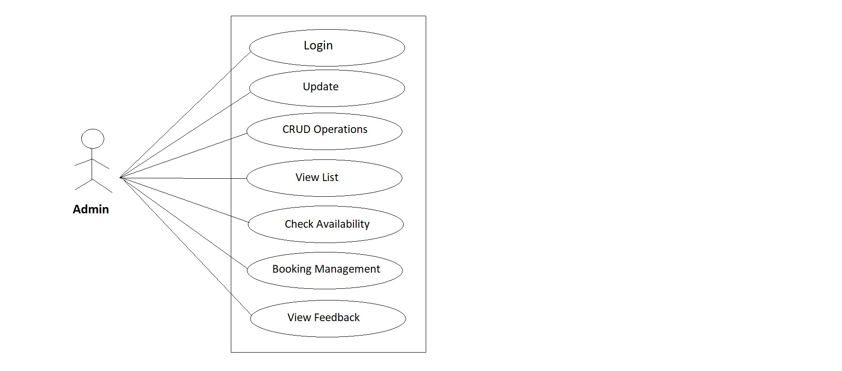

Fig. Use-Case Diagram for Admin

**5.2 User :**

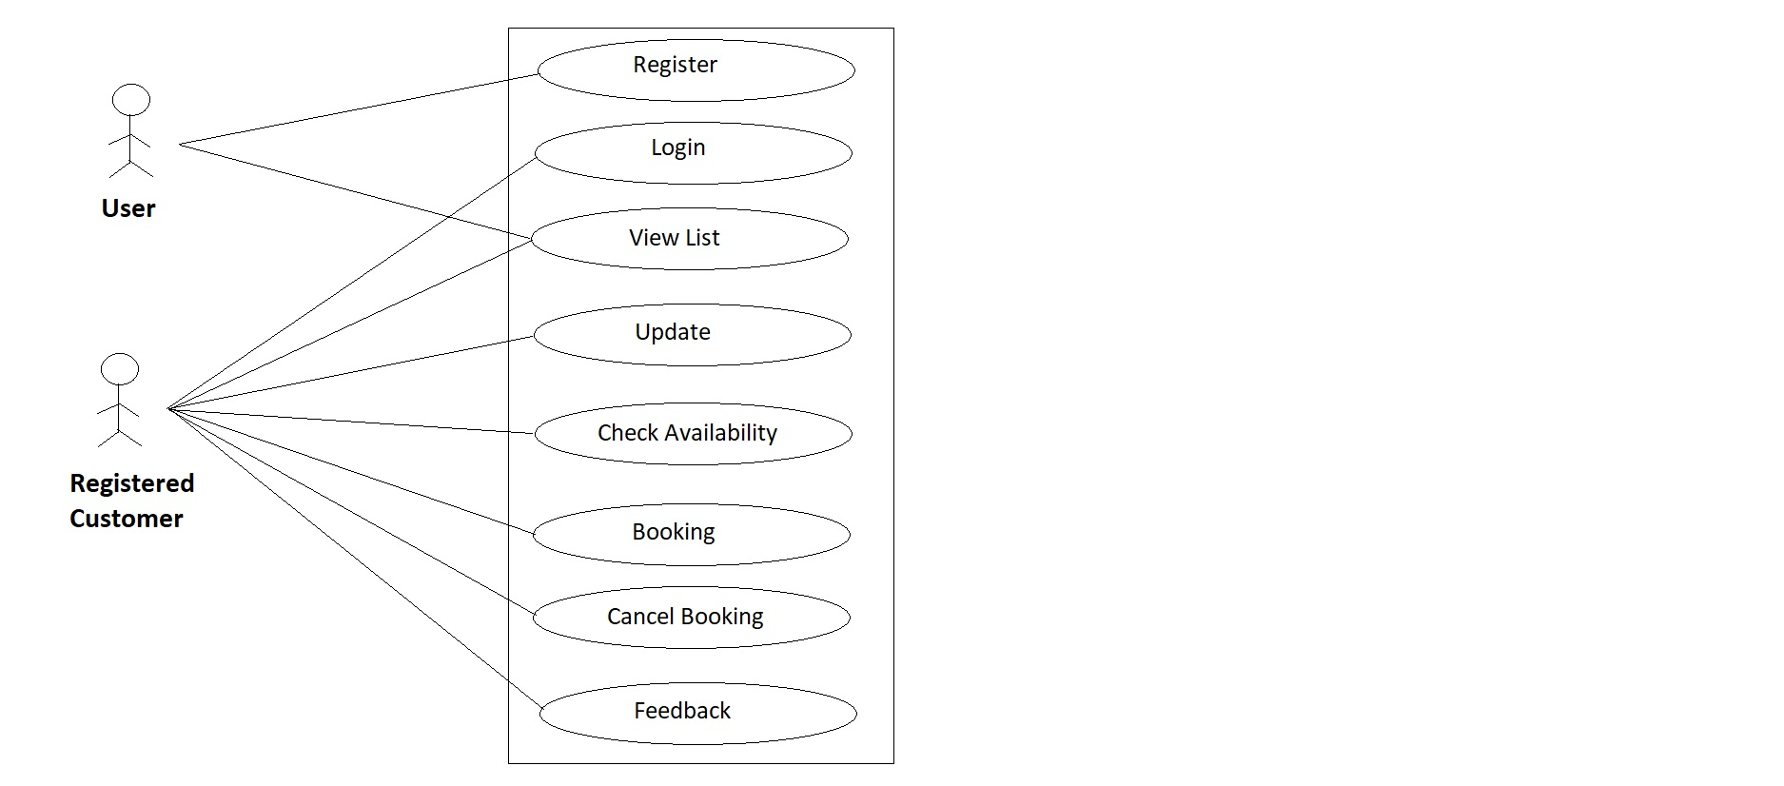

Fig. Use-Case Diagram for User

**5.3 Maid :**

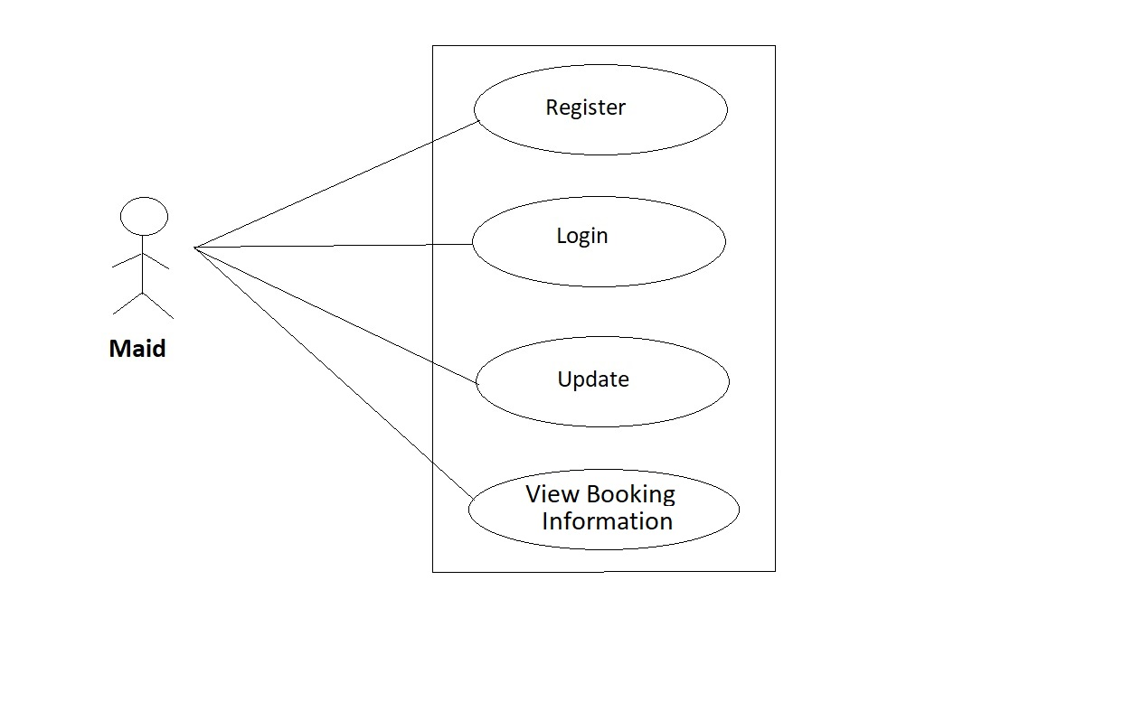

Fig. Use-Case Diagram for Maid

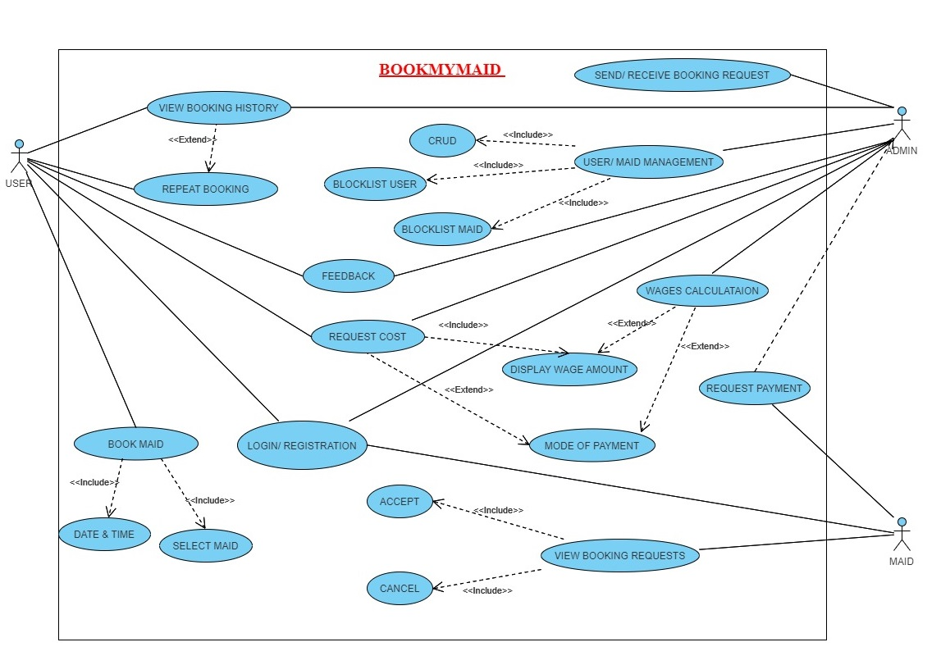

Fig. Use Case Diagram

**6. Database Design:**

**1] Maid**

|  |  |  |  |  |  |
| --- | --- | --- | --- | --- | --- |
| **Field** | **Type** | **Null** | **Key** | **Default** | **Extra** |
| **maid_id** | **int** | **NO** | **PRI** | **NULL** | **auto_increment** |
| **maid_address** | **varchar(255)** | **YES** |  | **NULL** |  |
| **maid_adhar_card** | **varchar(255)** | **YES** |  | **NULL** |  |
| **maid_age** | **int** | **YES** |  | **NULL** |  |
| **maid_city** | **varchar(255)** | **YES** |  | **NULL** |  |
| **maid_email_id** | **varchar(255)** | **YES** |  | **NULL** |  |
| **maid_experience** | **int** | **YES** |  | **NULL** |  |
| **maid_mobile_no** | **varchar(255)** | **YES** |  | **NULL** |  |
| **maid_name** | **varchar(255)** | **YES** |  | **NULL** |  |
| **maid_password** | **varchar(255)** | **YES** |  | **NULL** |  |
| **maid_pincode** | **varchar(255)** | **YES** |  | **NULL** |  |
| **maid_police_**  **verification_certificate** | **varchar(255)** | **YES** |  | **NULL** |  |
| **maid_username** | **varchar(255)** | **YES** |  | **NULL** |  |
| **month_charges** | **int** | **YES** |  | **NULL** |  |
| **services_id** | **int** | **YES** | **MUL** | **NULL** |  |

**2] User**

|  |  |  |  |  |  |  |
| --- | --- | --- | --- | --- | --- | --- |
| **Field** | **Type** | **Null** | **Key** | **Default** | **Extra** |  |
| **user_id** | **int** | **NO** | **PRI** | **NULL** | **auto_increment** |  |
| **user_address** | **varchar(255)** | **YES** |  | **NULL** |  |  |
| **user_adhar_card** | **varchar(255)** | **YES** |  | **NULL** |  |  |
| **user_city** | **varchar(255)** | **YES** |  | **NULL** |  |  |
| **user_email_id** | **varchar(255)** | **YES** |  | **NULL** |  |  |
| **user_family_members** | **int** | **YES** |  | **NULL** |  |  |
| **user_gender** | **varchar(255)** | **YES** |  | **NULL** |  |  |
| **user_mobile_no** | **varchar(255)** | **YES** |  | **NULL** |  |  |
| **user_name** | **varchar(255)** | **YES** |  | **NULL** |  |  |
| **user_password** | **varchar(255)** | **YES** |  | **NULL** |  |  |
| **user_pincode** | **varchar(255)** | **YES** |  | **NULL** |  |  |
| **user_rooms** | **int** | **YES** |  | **NULL** |  |  |
| **user_username** | **varchar(255)** | **YES** |  | **NULL** |  |  |

**3] Services**

|  |  |  |  |  |  |
| --- | --- | --- | --- | --- | --- |
| **Field** | **Type** | **Null** | **Key** | **Default** | **Extra** |
| **services_id** | **int** | **NO** | **PRI** | **NULL** | **auto_increment** |
| **base_charges** | **Int** | **YES** |  | **NULL** |  |
| **services_name** | **Varchar(255)** | **YES** |  | **NULL** |  |

**4] Booking_Info**

|  |  |  |  |  |  |
| --- | --- | --- | --- | --- | --- |
| **Field** | **Type** | **Null** | **Key** | **Default** | **Extra** |
| **booking_info_id** | **int** | **NO** | **PRI** | **NULL** | **auto_increment** |
| **end_date** | **date** | **YES** |  | **NULL** |  |
| **maid_booking_date** | **date** | **YES** |  | **NULL** |  |
| **maid_time_slots** | **varchar(255)** | **YES** |  | **NULL** |  |
| **month_charges** | **int** | **YES** |  | **NULL** |  |
| **start_date** | **date** | **YES** |  | **NULL** |  |
| **services_id** | **int** | **YES** | **MUL** | **NULL** |  |
| **maid_id** | **int** | **YES** | **MUL** | **NULL** |  |
| **user_id** | **int** | **YES** | **MUL** | **NULL** |  |

**5] Maid_review**

|  |  |  |  |  |  |
| --- | --- | --- | --- | --- | --- |
| **Field** | **Type** | **Null** | **Key** | **Default** | **Extra** |
| **maid_review_id** | **int** | **NO** | **PRI** | **NULL** | **auto_increment** |
| **maid_comments** | **varchar(255)** | **YES** |  | **NULL** |  |
| **maid_rating** | **varchar(255)** | **YES** |  | **NULL** |  |
| **maid_id** | **int** | **YES** | **MUL** | **NULL** |  |
| **user_id** | **int** | **YES** | **MUL** | **NULL** |  |

**8. Snapshots:**

**8.1 Home Page:**

Following snapshot shows the Home page for Online Maid Booking System

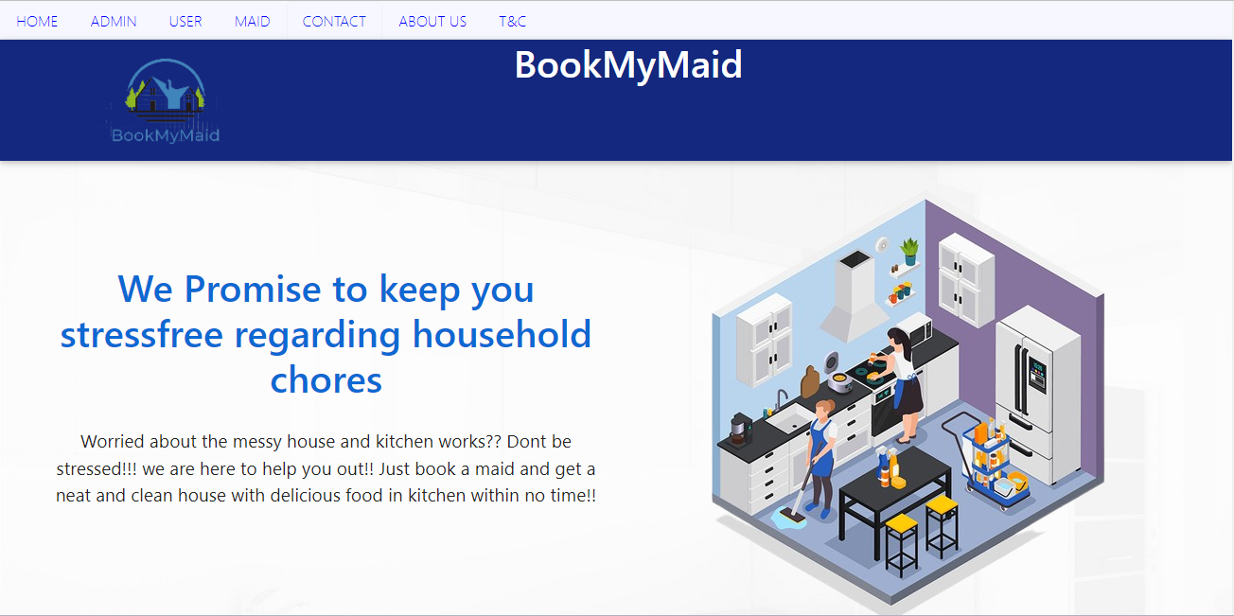

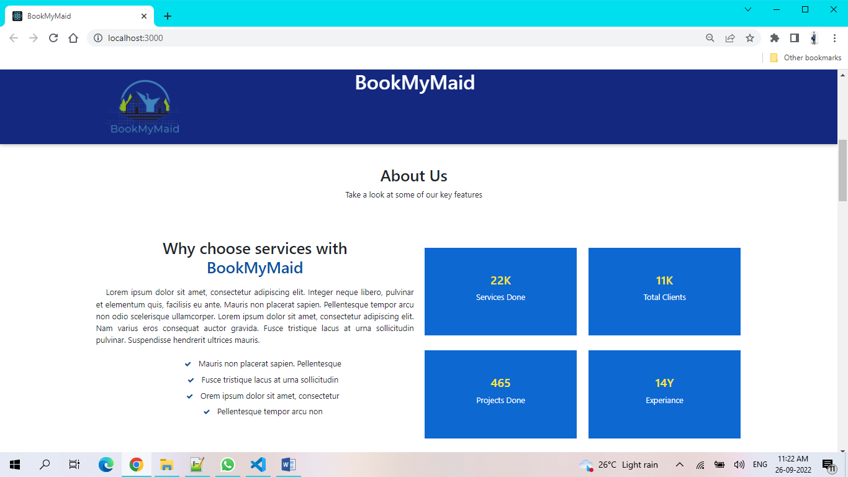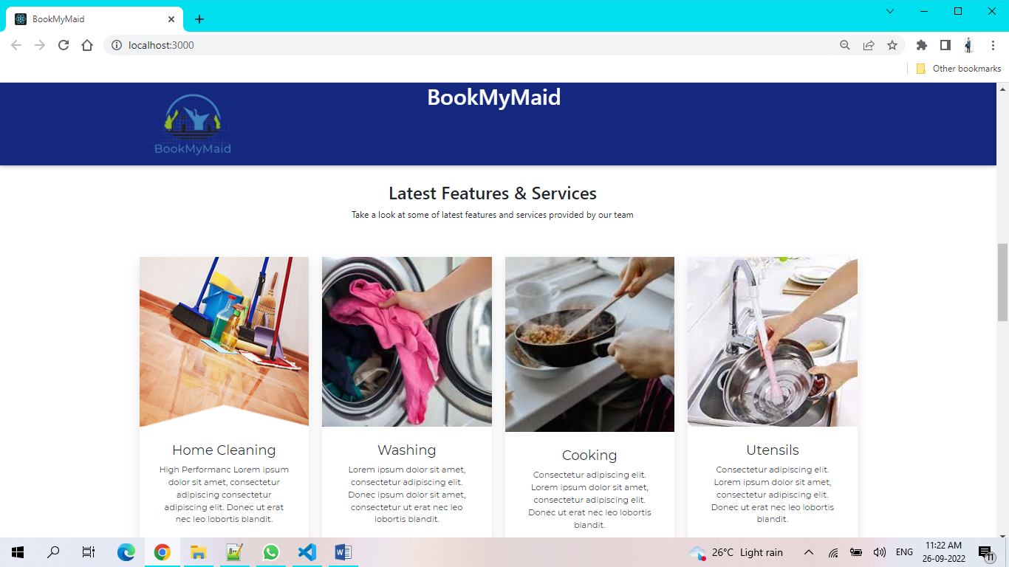

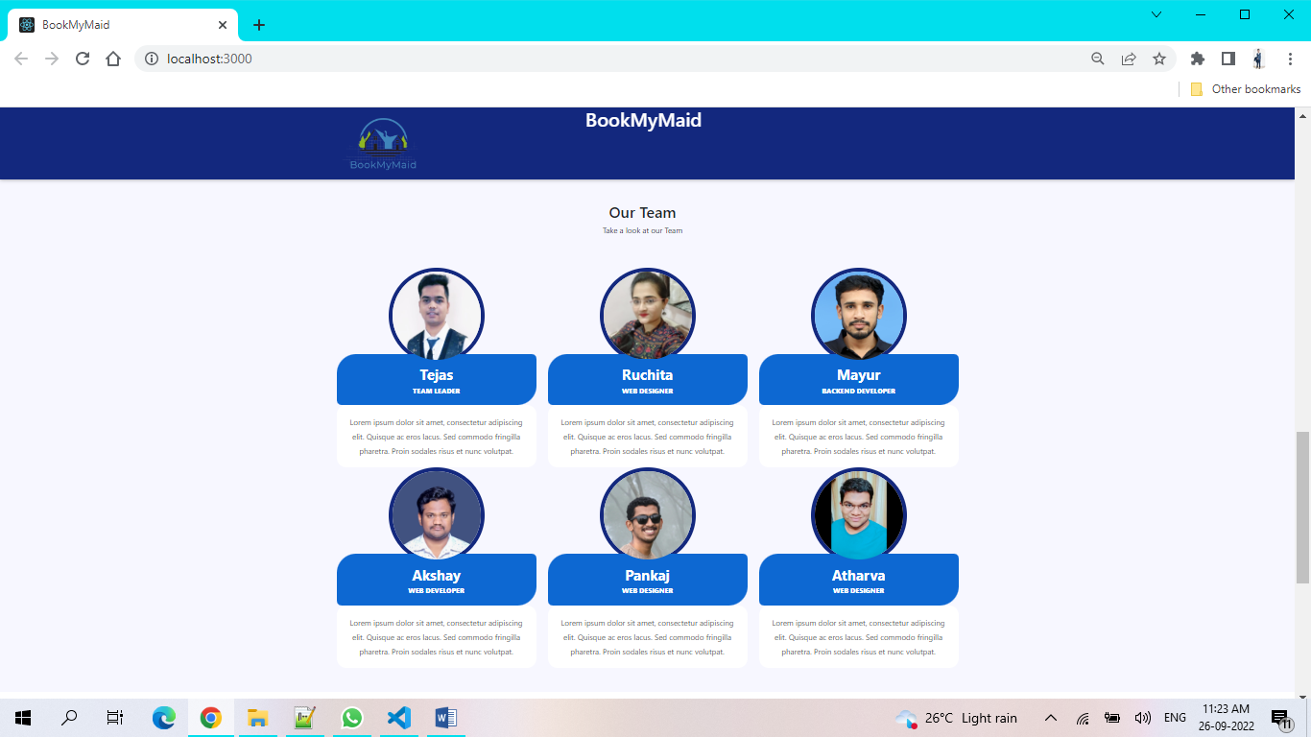

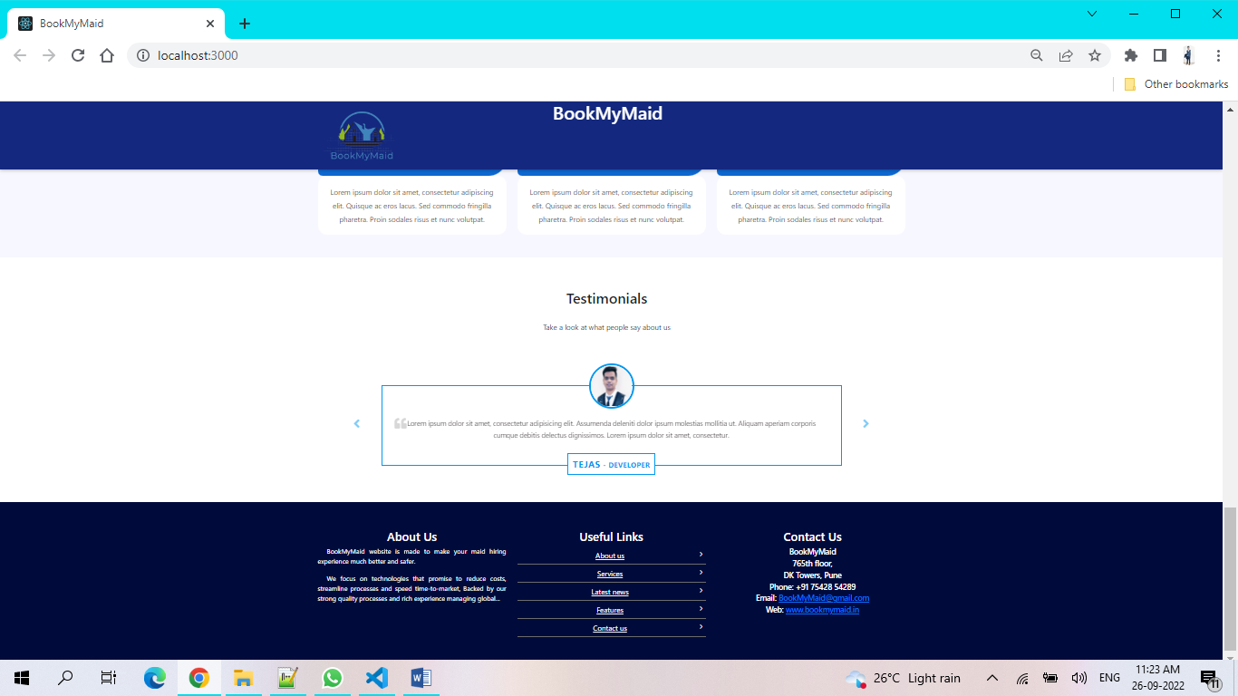

This page contains following controls

* Home
* Admin
* User
* Maid
* Contact
* About Us
* Terms And Conditions

**8.2 Contact And About Page**

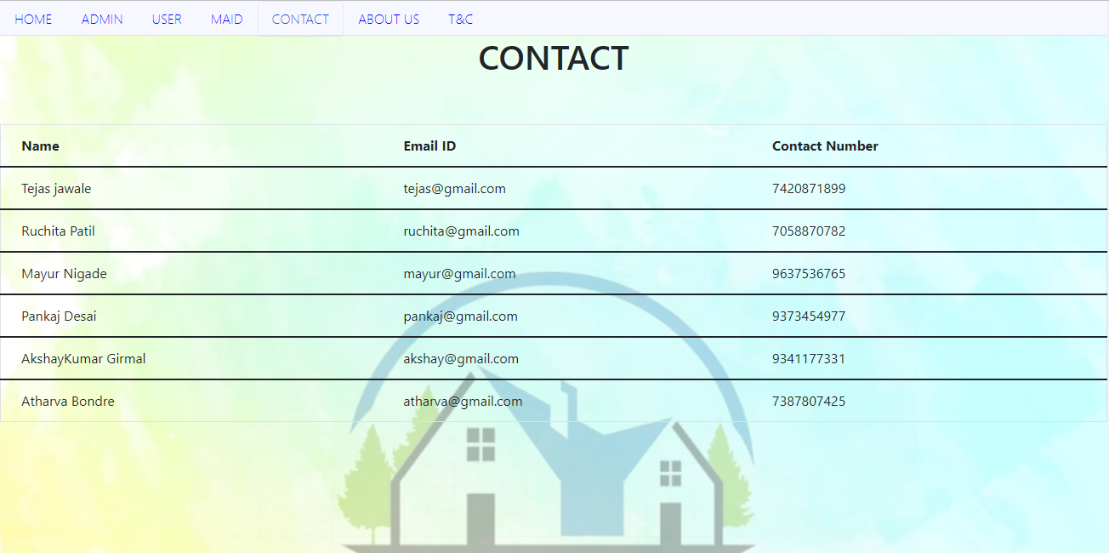

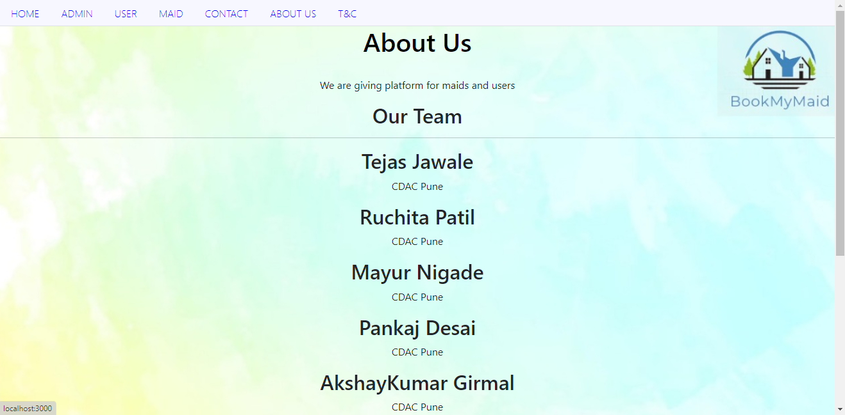

**8.3 Login Page**

Following snapshot shows the Login page for Admin

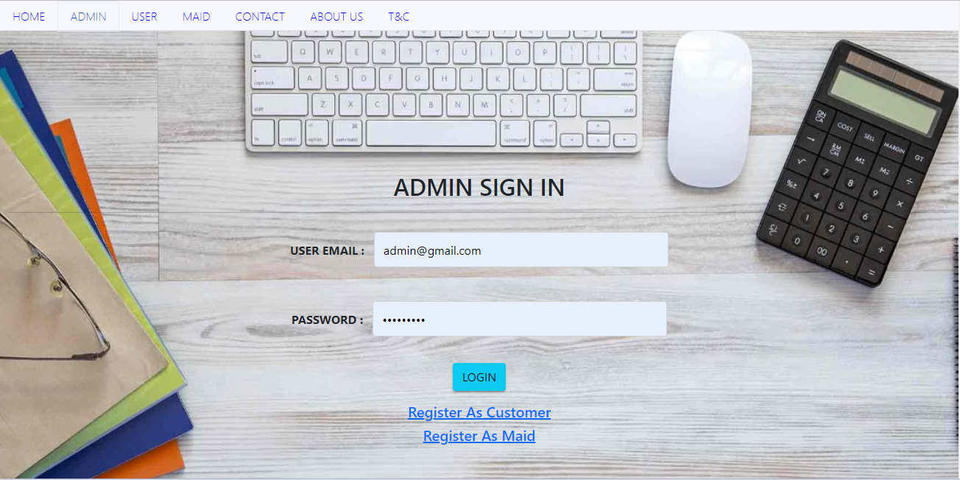

Following snapshot shows the Login page for User

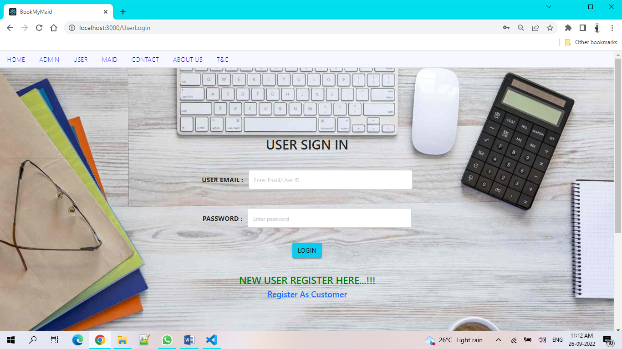

Following snapshot shows the Login page for Maid

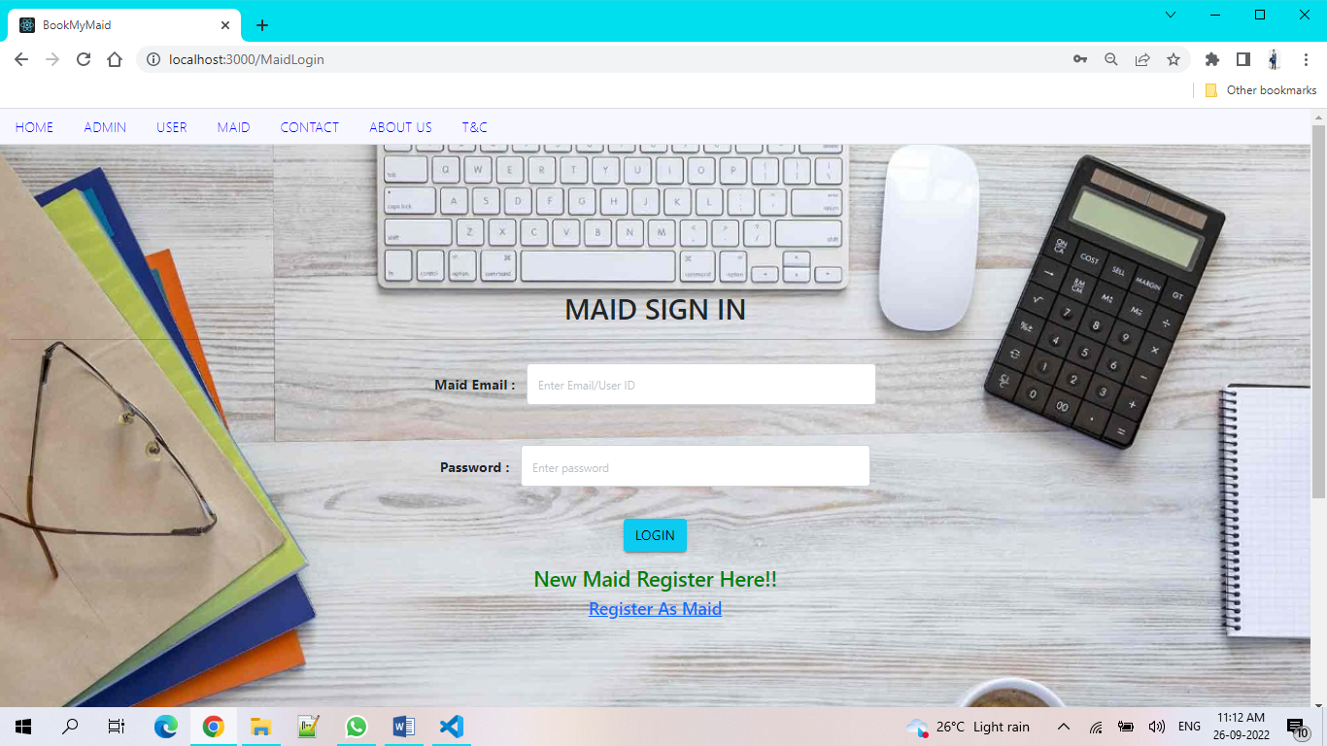

**8.4 Customer Registration Page**

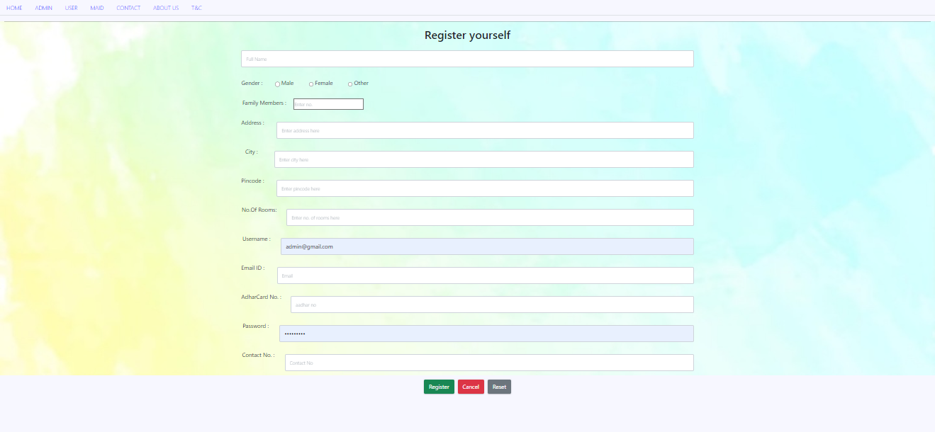

**8.5 Maid Registration Page**

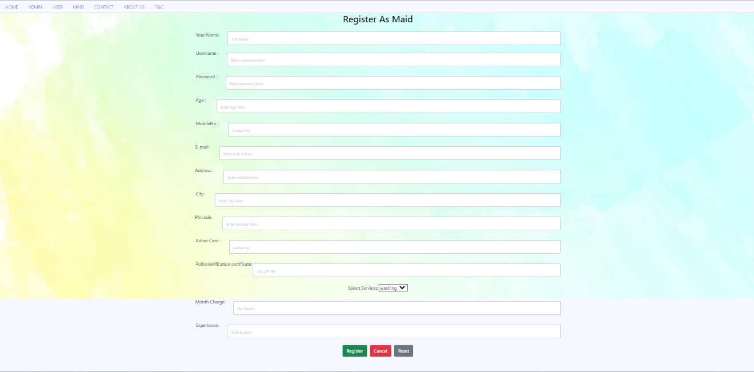

**8.6Customer Booking Maid**

**8.6.1 Customer Home page After Successful login**

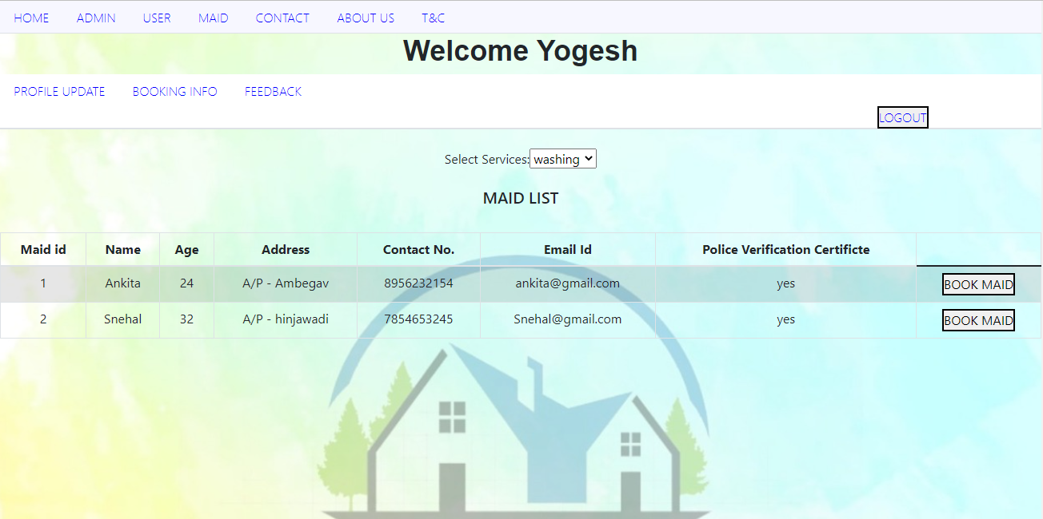

**8.6.2 Customer Viewing Maid for Category Cleaning**

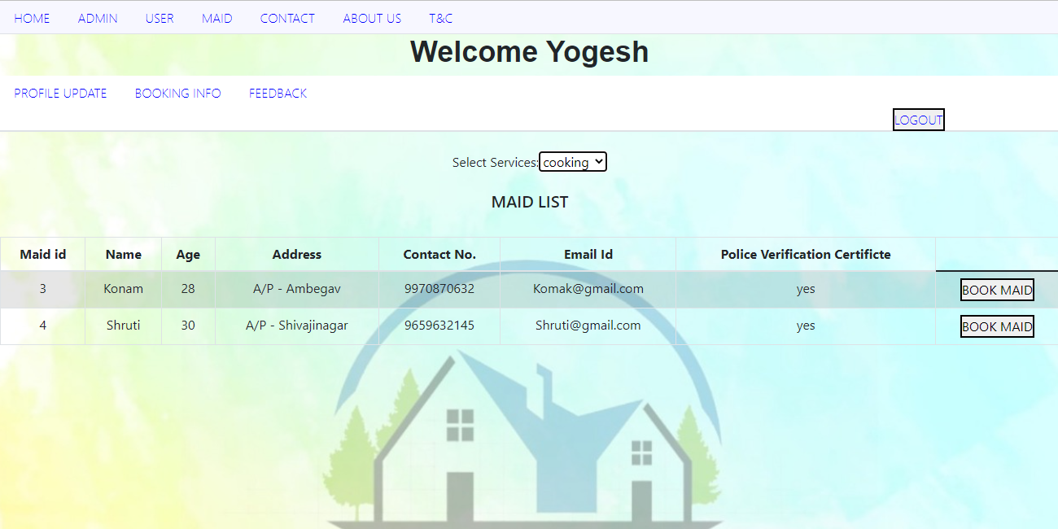

**8.6.3Customer Viewing Maid for Category Cooking**

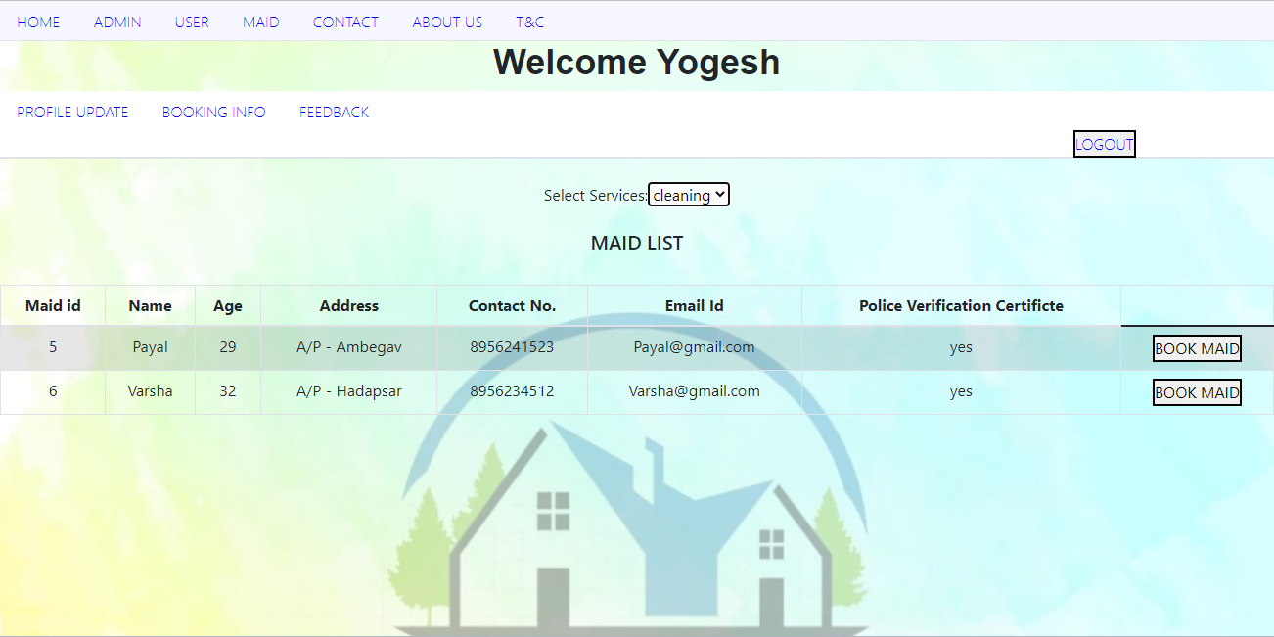

**8.6.4 Booking Page**

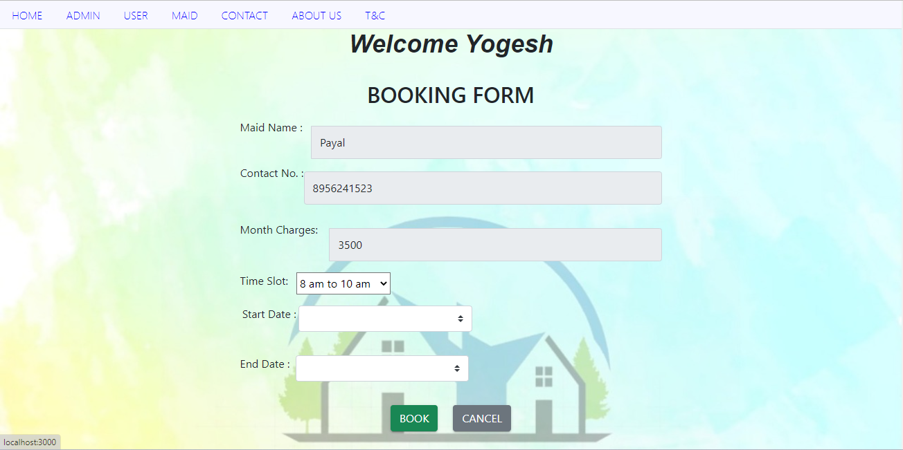

**8.6.5 Booking Info (the bookings made by customer)**

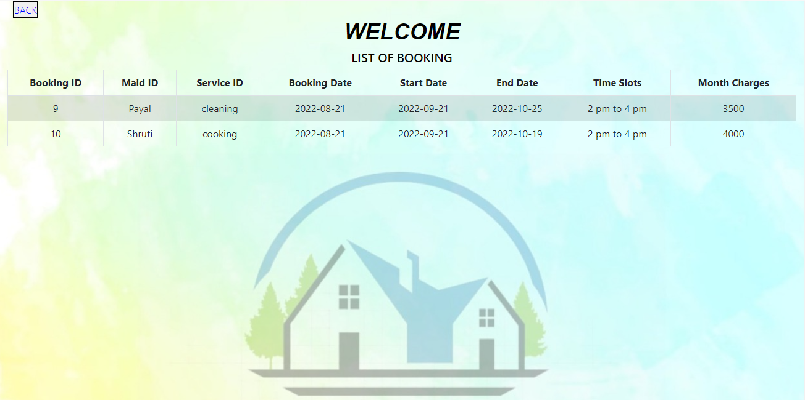

**8.6.6Customer Feedback Form**

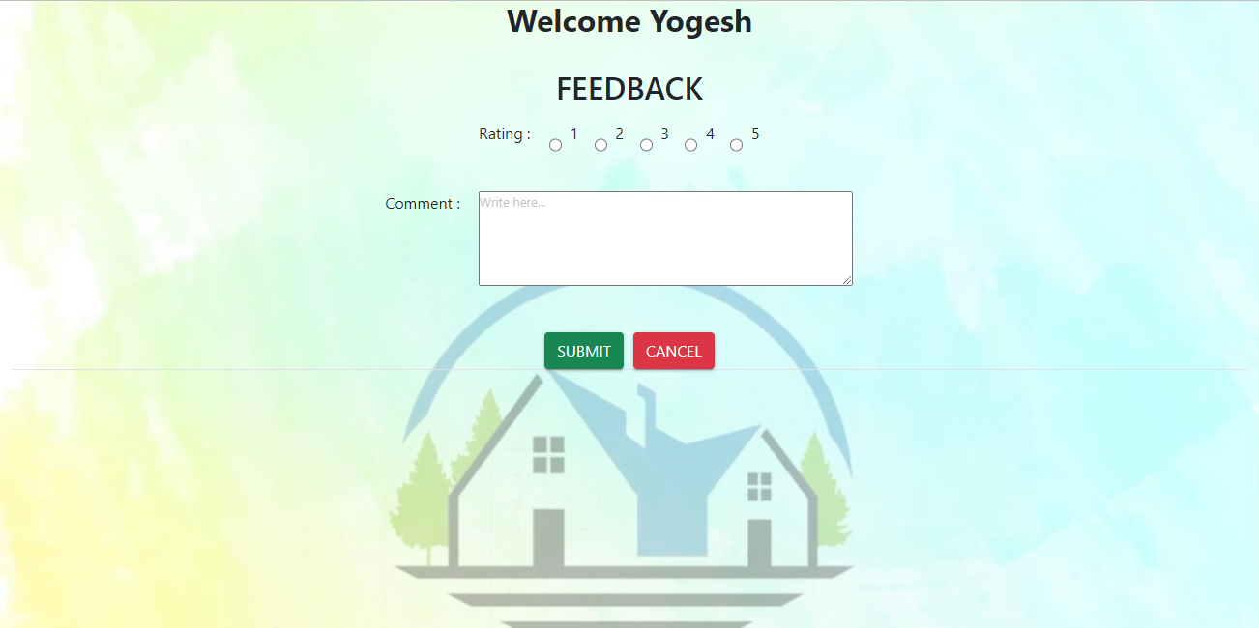

**8.6.7customer Personal Info(customer can update personal info )**

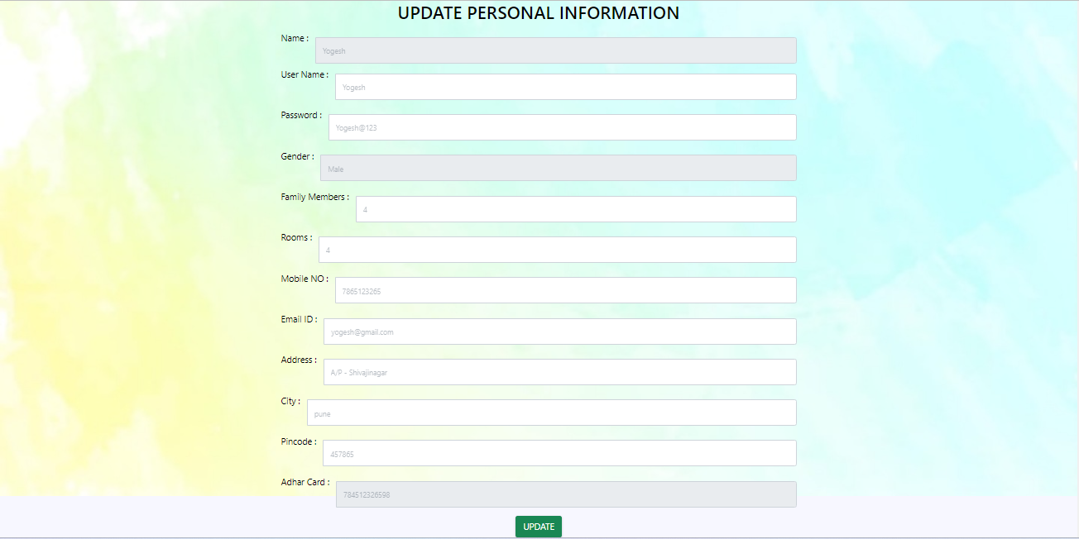

**8.7.7 Maid Update Profile Page updated by Admin**

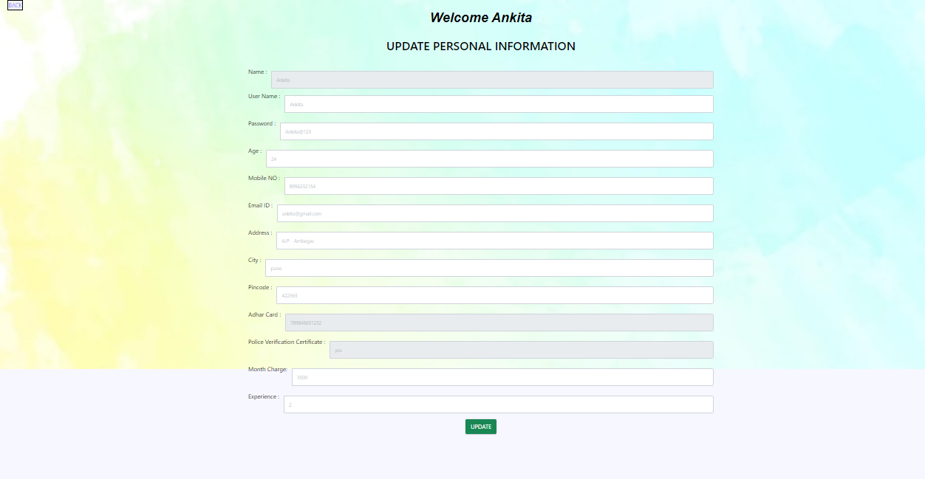

**8.8 Admin**

**8.8.1 Admin Home Page**

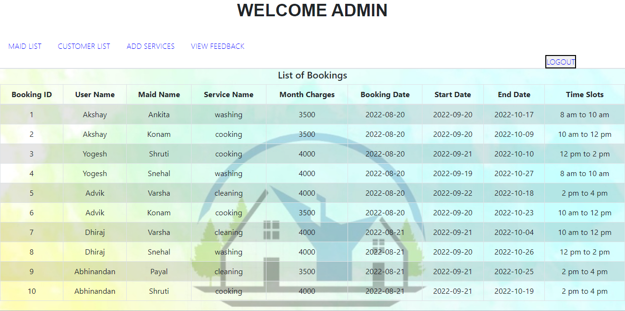

**8.8.2 Maid Details for Admin**

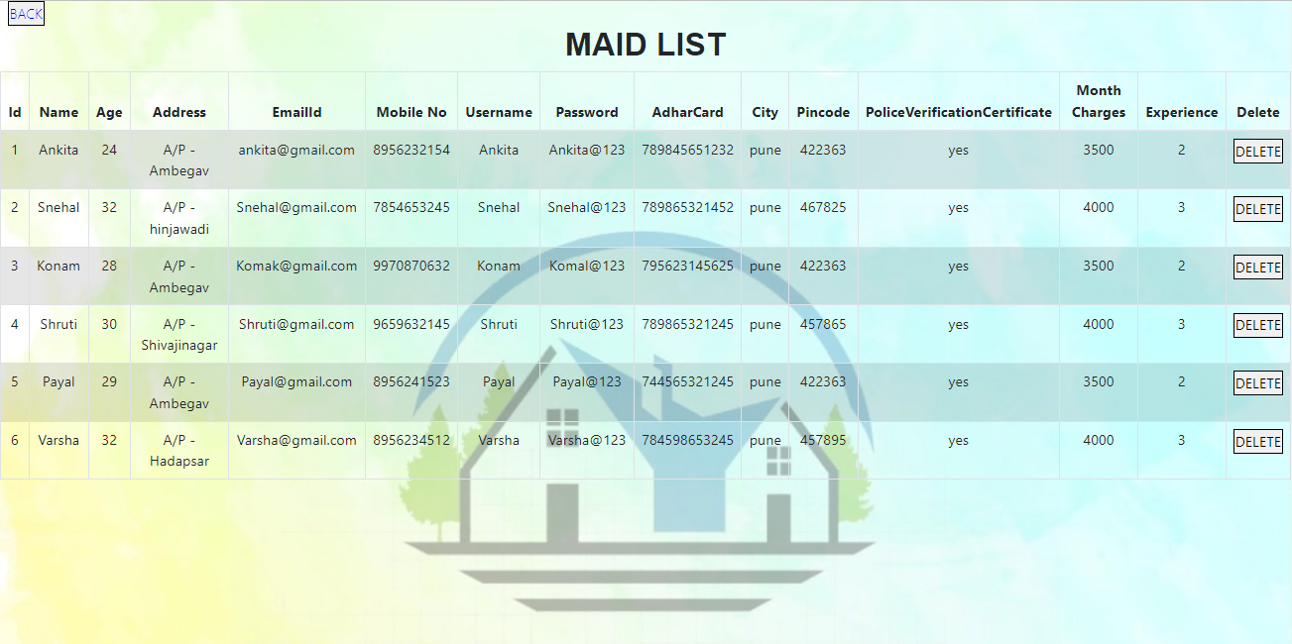

**8.8.3 Maid Profile Page**



**8.8.4 Customer Details Page**

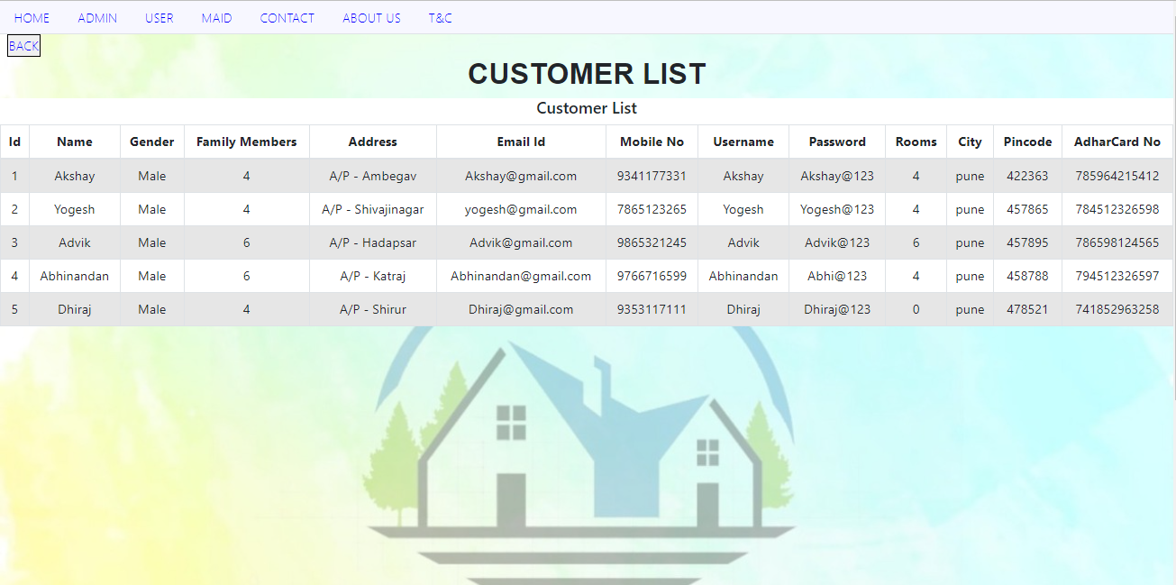

**8.8.5 List of Feedback given by customer**

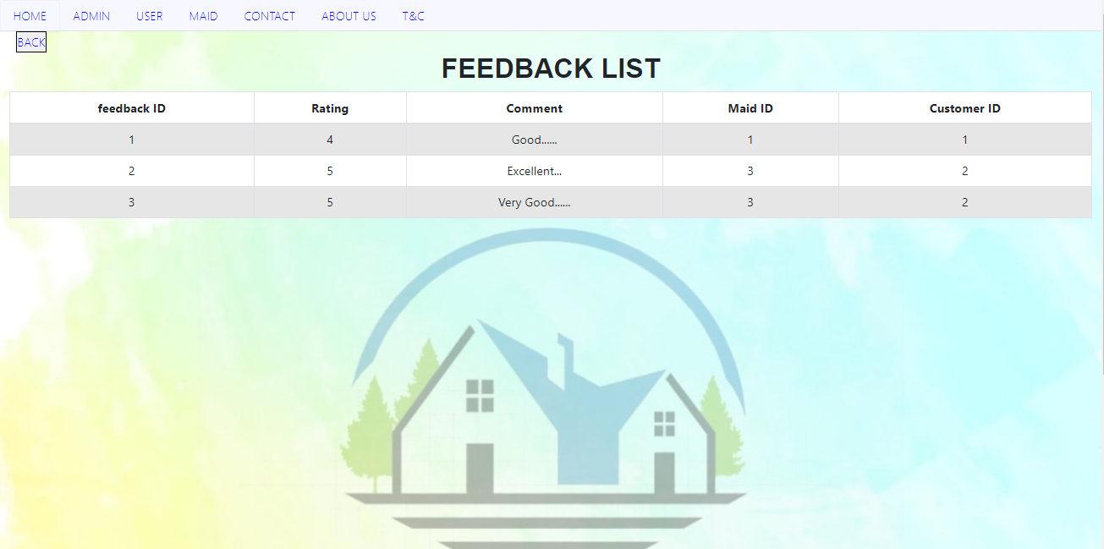

**9. Future Scope**

* Will add more categories in worklist of Maid.
* Will add another functionality of Maid Blacklisting.
* Admin can remove Blacklist maids from Application.
* Slots management should be done in proper way.
* Will add online payment functionality, e.g UPI’s

**10. CONCLUSION**

* Learnt the flow of how a project works.
* Initially have so much brainstorming about the project.
* Got to know how many processes are going on inside the project.
* Working with many technologies and making them work together.
* Got to know about various issues that can occur while development and how to resolve them.
* For several years we saw many websites but now we know how everything works.
* It was a great experience to work with different technologies and teammates.